Third Task of Internship
- Create a MYSQL database
- Connect website with DB
- Create Login and Register page
- Make sure Register fields should save in DB USER table.
Step1: start Apache and MySQL in Xampp
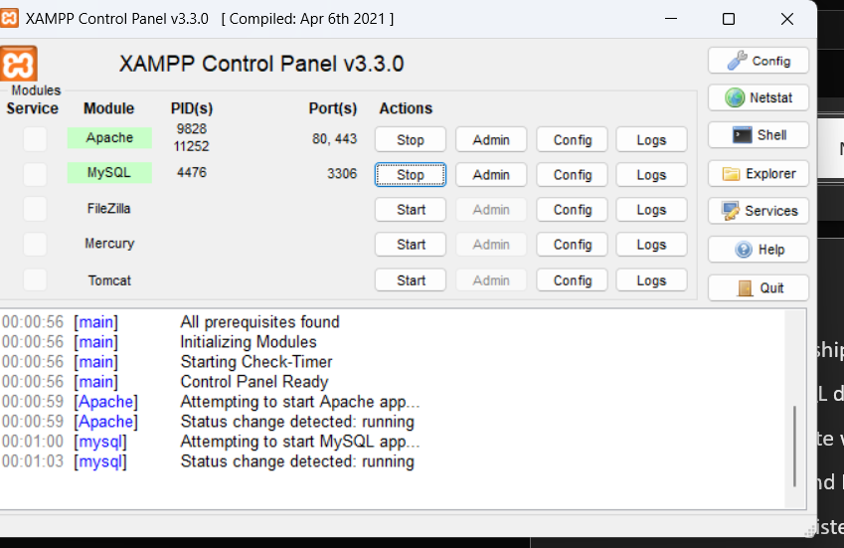
Step2: Open browser and go to
http://localhost/phpmyadmin
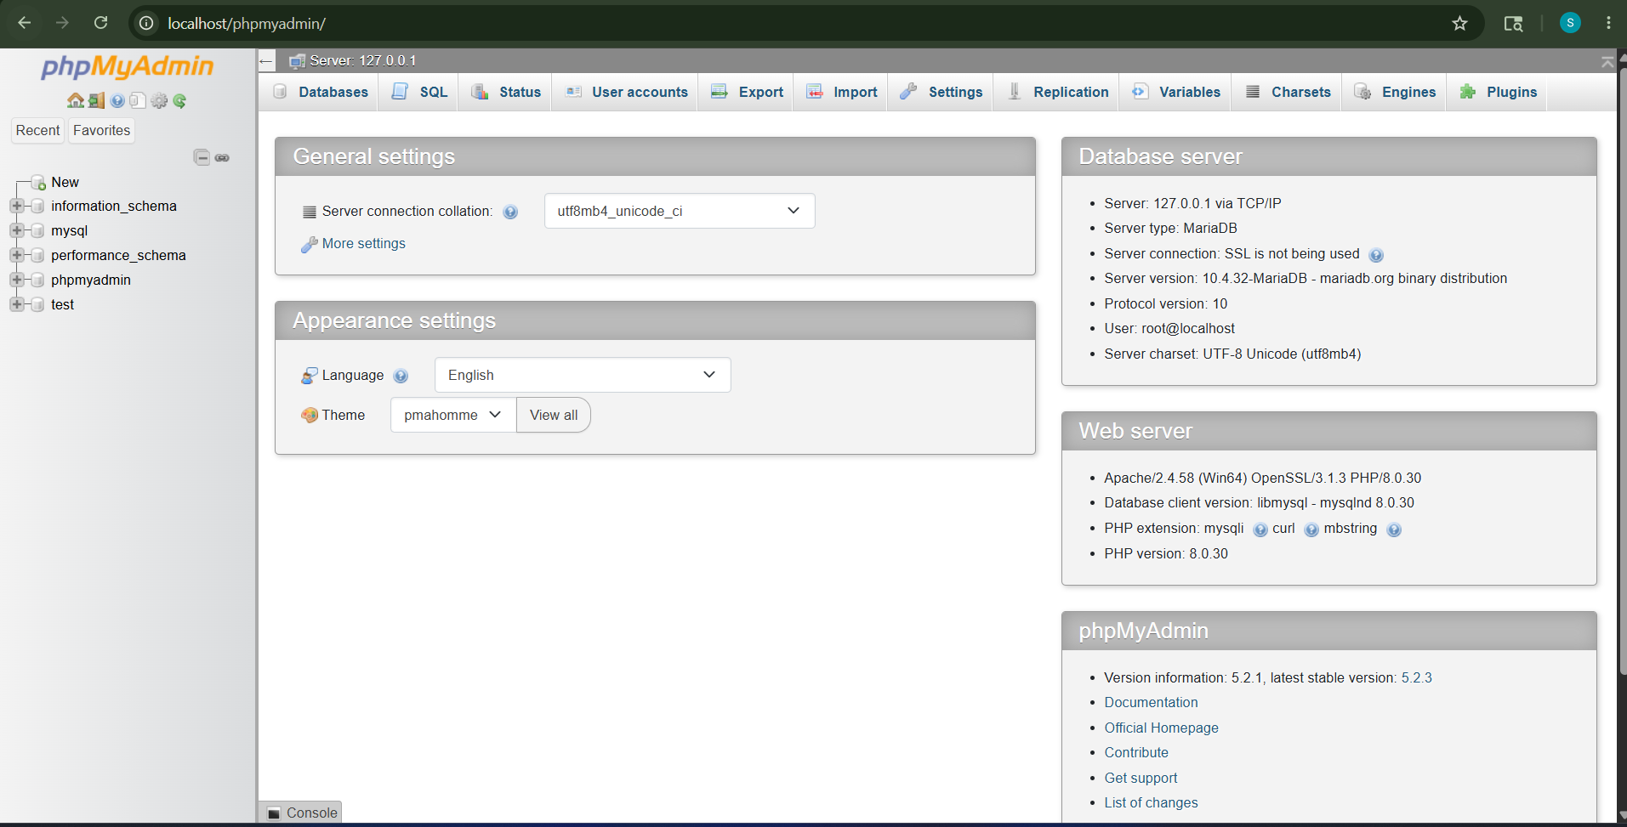
Step3: click new then type database name and click create
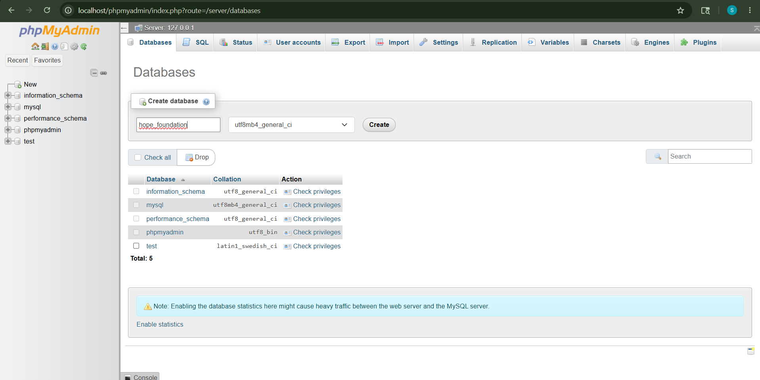
Step4: click sql and the create user and click go
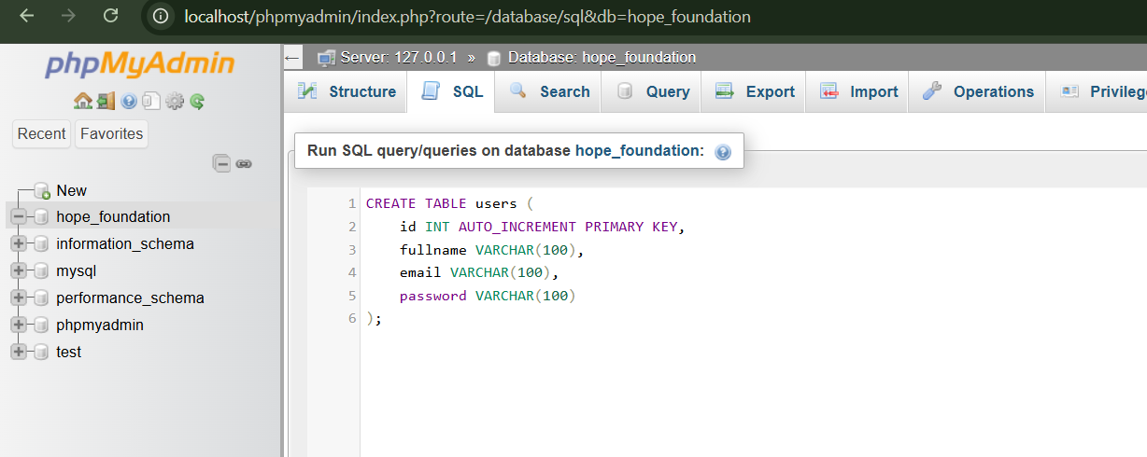
Step5: Create db.php
Inside your website folder create

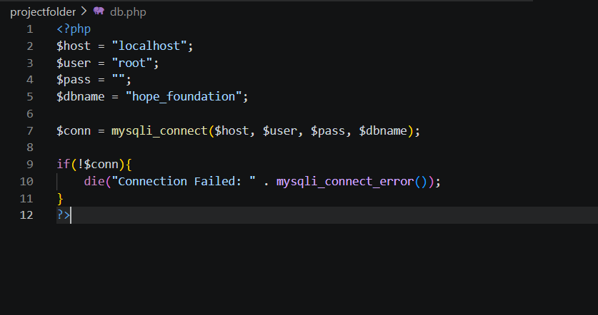
Step6: create register.php
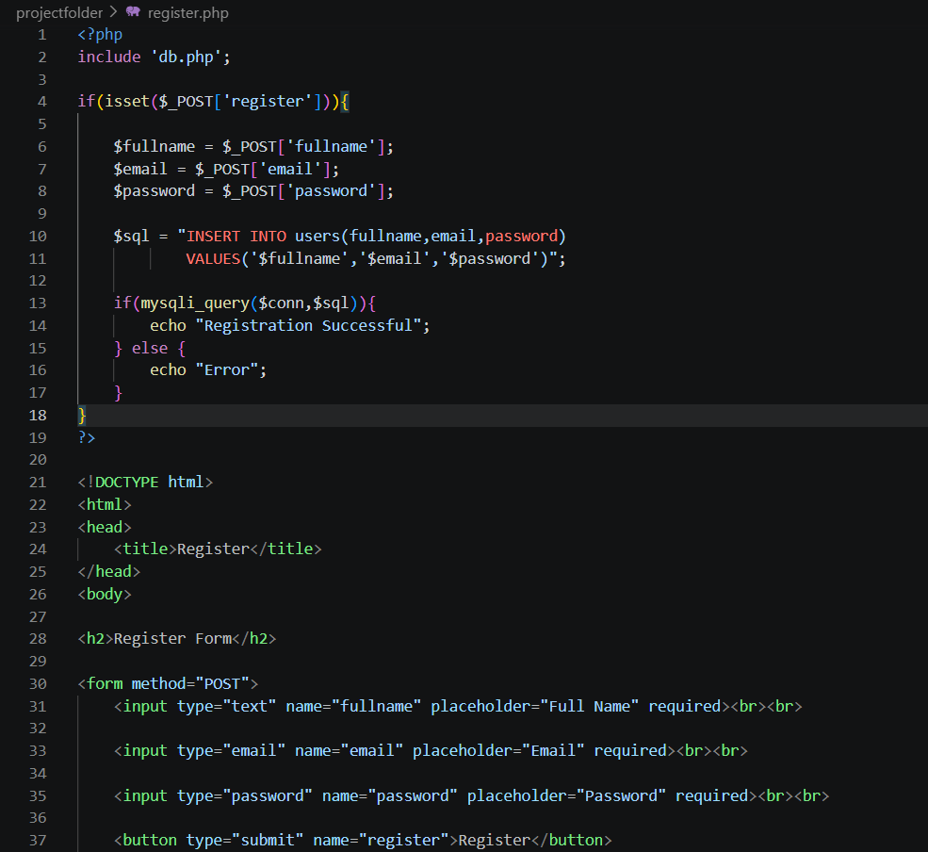
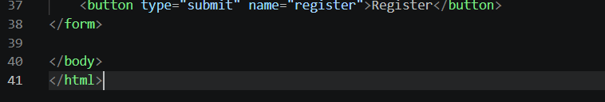
Step7: create login.php
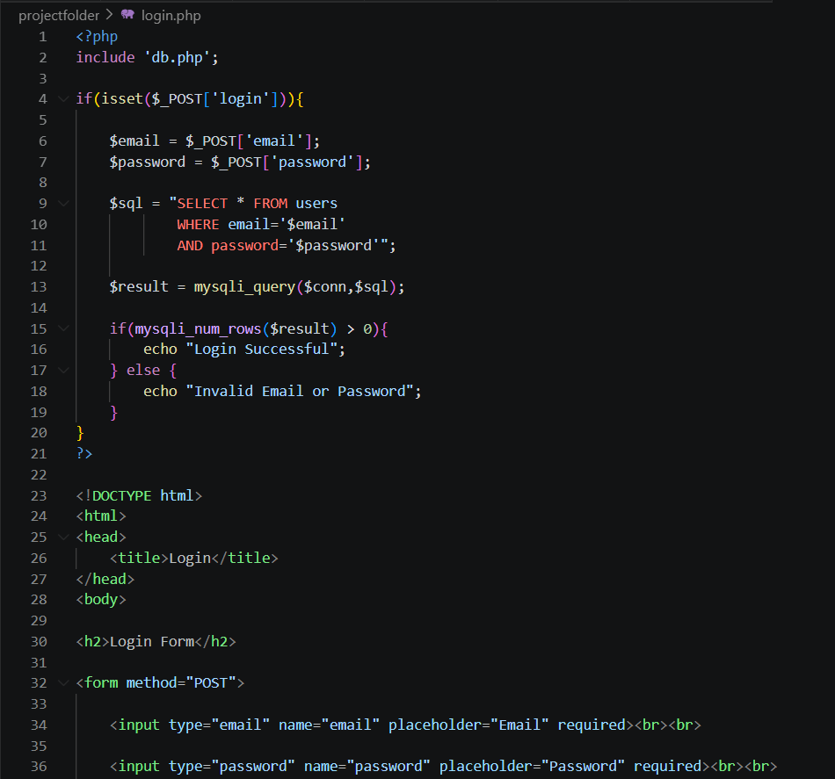
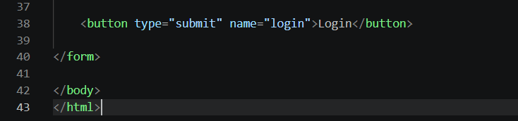
Step8: run website
http://localhost/projectfolder/register.php
http://localhost/projectfolder/login.php
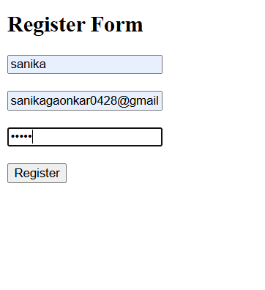
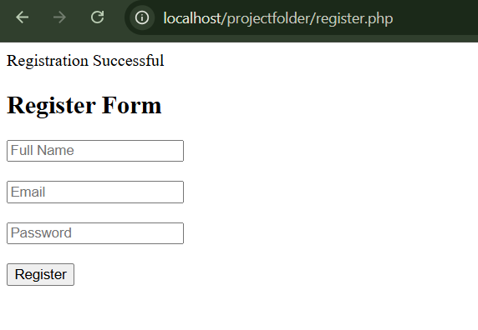
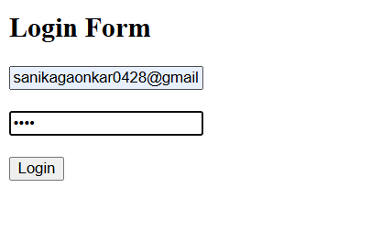
Step9: Open phpMyAdmin then Click hope_foundation and Open users table, we will see saved user data
